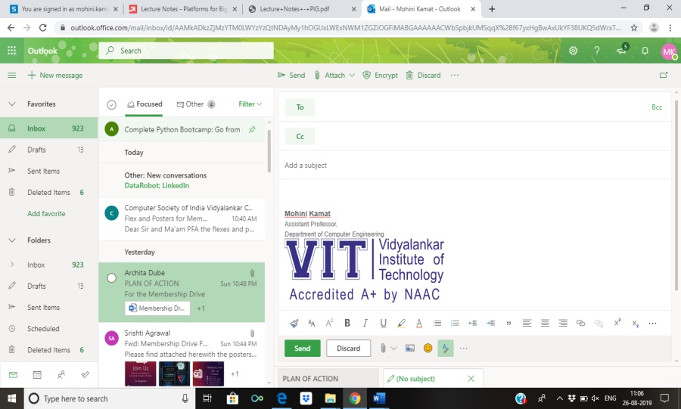
Semester | T.E. Semester VI– SPCC
Subject | Software Engineering
Subject Professor In-charge | Prof. Pankaj Vanvari
Assisting Teachers | Prof. Pankaj Vanvari
Laboratory | M310B

Student Name | Deep Salunkhe
Roll Number | 21102A0014
TE Division | A

Title:
Tokenizer
Approach:

- Read Input: The program reads input from a file, tokenizes it, and stores it in a vector for processing.
- Tokenization: The input text is tokenized using a DFA approach. Each token is identified based on its type (identifier, integer literal, float literal, operator, etc.). Tokens are stored in a 2D vector along with their corresponding token ID.
- Symbol/Literal Table: The program maintains separate symbol/literal tables for identifiers, integer literals, and float literals. Each entry in these tables is associated with a pointer or identifier.
- Output: The program prints the tokens identified along with their token IDs and also displays the entries in the symbol/literal tables.

Implementation:

#include <iostream>
#include <fstream>
#include <vector>
#include <string>
#include <map>
using namespace std;

int readfile(string &fileName, vector<string> &input)
{
char ch;
fstream fp;
fp.open(fileName.c_str(), std::fstream::in);

if (!fp)
{
cerr << "Error opening the file: " << fileName << endl;
return 1; // Return an error code
}

string word;
while (fp >> noskipws >> ch)
{
if (ch == '\n')
{
input.push_back(word);
input.push_back(";");
word = "";
}
else if (ch == ' ')
{
input.push_back(word);
word = "";
}
else
{
word += ch;
}
}

input.push_back(word);

fp.close();
return 0; // Return success code
}

void print_vector_2D(vector<vector<string>> &input)
{
for (int i = 0; i < input.size(); i++)
{
cout << input[i][0] << " " <<"*->"<< input[i][1] << " ";
cout << endl;
}
cout << endl;
}

void print_vector(vector<string> &input)
{
for (int i = 0; i < input.size(); i++)
{
cout << input[i] << " ";
}
cout << endl;
}

void Tokenization(vector<string> &input, vector<vector<string>> &Tokensed, map<string, string> &keywords, map<string, int> &intcp, map<string, float> &floatcp, map<string, string> &idp)
{
int idc = 0;
int intcc = 0;
int floatcc = 0;

for (int i = 0; i < input.size(); i++)
{
if (input[i] == ";")
continue;

if (keywords.find(input[i]) != keywords.end())
{

Tokensed.push_back({keywords[input[i]], "NA"});
}
else
{
// if the value in not in keyword db it can be eithre identifier or constant

string curr = input[i];
char first_of_curr = curr[0]; // foc
int val_of_foc = first_of_curr - '0';
// cout << val_of_foc << endl;
if (val_of_foc >= 0 && val_of_foc <= 9)
{
bool isfloat = false;
for (auto x : curr)
{
if (x == '.')
isfloat = true;
}
if (isfloat)
{
float v = atof(curr.c_str());
string p = to_string(floatcc);
Tokensed.push_back({"3", p});
floatcp[p] = v;
floatcc++;
}
else
{
int v = stoi(curr);
string p = to_string(intcc);
Tokensed.push_back({"2", p});
intcp[p] = v;
intcc++;
}
}
else
{
string p = to_string(idc);

Tokensed.push_back({"1", p});
idp[p] = curr;
idc++;
}
}
}
}

void print_all_Symtabs(map<string, int> &intcp, map<string, float> &floatcp, map<string, string> &idp)
{
cout << "The integer constant pointer is: " << endl;
for (auto x : intcp)
{
cout << x.first << "->" << x.second << endl;
}
cout << endl;

cout << "The float constant pointer is: " << endl;
for (auto x : floatcp)
{
cout << x.first << "->" << x.second << endl;
}
cout << endl;

cout << "The identifier pointer is: " << endl;
for (auto x : idp)
{
cout << x.first << "->" << x.second << endl;
}
cout << endl;
}

int main()
{
// Database starts
map<string, string> keywords;
keywords["int"] = "INT";
keywords["float"] = "FLOAT";
keywords["+"] = "4";
keywords["-"] = "5";
keywords["*"] = "6";
keywords["/"] = "7";
keywords["="] = "9";
keywords["^"] = "8";
keywords["("] = "10";
keywords[")"] = "11";

// 1 for identifiers

// pointer to intc
map<string, int> intcp;
// pointer ot intf
map<string, float> floatcp;
// pointer to identifier
map<string, string> idp;

// Database ends
string inputFile;
vector<string> input;
vector<vector<string>> Tokensed;

cout << "Enter the name of the file: ";
cin >> inputFile;
readfile(inputFile, input);

cout << "The input file is: " << endl;
print_vector(input);

Tokenization(input, Tokensed, keywords, intcp, floatcp, idp);
cout << "The tokens are: " << endl;
print_vector_2D(Tokensed);

print_all_Symtabs(intcp, floatcp, idp);

return 0;
}

End Result:

Input file:
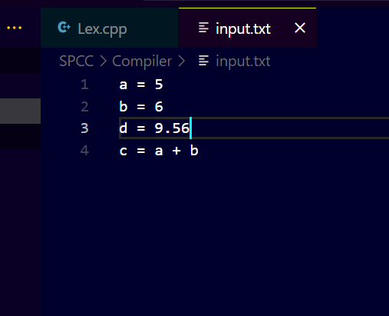

Output :
